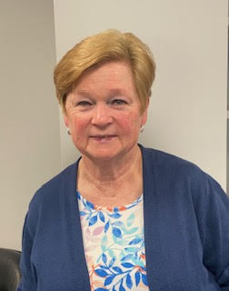

**Vote Patti G for BOE 2025!**

My name is Pat Greenhall. My family has lived in Mechanicville since 1988, when my husband Frank (aka “Doc”) was appointed Mechanicville High School principal, then later Superintendent of Schools. I began teaching here in the district that same year and did so until my retirement in 2011. Our family has been very involved in the school and community since we moved here, including my own service on the school board upon my retirement.

Several weeks ago, I saw what was being proposed for the budget for the upcoming school year. Among other undisclosed cuts, I read about the proposal to cut four elementary teachers. I was very upset, to say the least.

Around this time, I was contacted to see if I’d consider running for the school board again. It was an easy “yes” for me: I want to be a champion for what is right for the students and employees of this district, as well as the taxpayers. I will not just sit back and accept the easy way, especially when it is not the right way. And what had been proposed to us definitely did not feel right.

So, if you live in the Mechanicville School District, please come up and vote for the budget and vote for me for the school board.  As my daughter would say, “Vote Patti G for BOE! " And please encourage your friends and family members to vote for me too!

Thank you,

Pat Greenhall

 Hi, I’m Aaron Currado. I’m a parent, a business leader, and a proud

member of the Mechanicville community for the past 17 years. My wife,

Melissa, and I live here with our daughter Liliana, a freshman at MHS.

I’m running for the Board of Education because I believe fairness means

giving every student and educator what they need to succeed - whether

that’s in the classroom, on the field, or on the stage.

I grew up in the Mohonasen School District, where I was deeply involved in

music and the arts, played multiple sports, and served my community as a

Boy Scout and volunteer firefighter, later becoming a State Fire Instructor.

These experiences shaped my commitment to service and the importance

of well-rounded opportunities for youth.

Professionally, I bring over 25 years of experience in business leadership, managing global teams, complex systems, and strategic initiatives. Today, I serve as Senior Manager of Global Supply Quality & Compliance at Plug Power. My background also includes work on defense contracts, where I’ve learned the value of innovation, accountability, and collaboration—qualities I believe are essential in education.

Beyond the workplace, I’m actively involved in STEM education and workforce development, serving as a Workforce Development Ambassador and a Regional Judge for the Future City Competition. These roles keep me closely connected to local schools, career fairs, and industry partnerships, which helping students gain the skills they need for tomorrow’s workforce.

You’ll often find me volunteering locally, supporting the Mechanicville Drama Booster Foundation, attending school events, helping friends and family with tech issues, or chasing our mini golden-doodle between rehearsals and games.

I believe my broad experience across academics, the arts, and athletics gives me a well-rounded perspective. I’m passionate about ensuring every student, regardless of background or interest, has access to programs that inspire, challenge, and prepare them for success.

If elected, I will advocate for:

Expanded arts and extracurricular programs, ensuring creativity and self-expression remain vital in our schools.

Sustainable youth sports, encouraging healthy lifestyles, teamwork, and school spirit. Career and technical pathways, partnering with local industries to connect students to real-world opportunities.

Transparency and engagement, making sure families feel informed, included, and heard. Strategic, responsible planning, using my professional expertise to help build a resilient, future-ready district for educators and students.

I am committed to **listening actively, leading with integrity**, and making decisions with students, teachers, and families at the center.

It would be an honor to earn your **trust and your vote**. Together, we can build a strong foundation for all students to flourish—academically, athletically, and artistically- and for educators to thrive and feel supported, respected, and empowered to do their best work.



Hello, my name is Alyssa Corbett and I am running to be on the Mechanicville Board of Education. I was born and raised here in Mechanicville, and was lucky enough to attend MES and MHS from kindergarten through 12th grade where I participated in cheer, drama, literary magazine (I'm really aging myself here!) and various other programs that shaped who I am today.  After graduating from MHS I went on to earn a broadcast journalism degree, and learned how important it is to be a good and transparent communicator.

I work as a service advisor at Mohawk Chevrolet, and also own a face painting business with which I attend local events like family day. I’m a proud parent of three children in

4th, 5th, and 8th grade, and I’ve been deeply involved behind the scenes as part of the drama club production team with my daughter, Sage. When I am not working, I enjoy doing a little bit of everything with my family including going to hockey games, shows, concerts, comic cons, and volunteering with various charities.

As a mom, small business owner, and active member of our school community, I hope to bring a hands-on, creative perspective to the Board of Education. I’m running to champion inclusion in education, support the arts and sports programs, and stand with our dedicated educators. I believe every child deserves a vibrant, welcoming school where they can learn, express themselves, and succeed. I hope you will support me in making this happen!

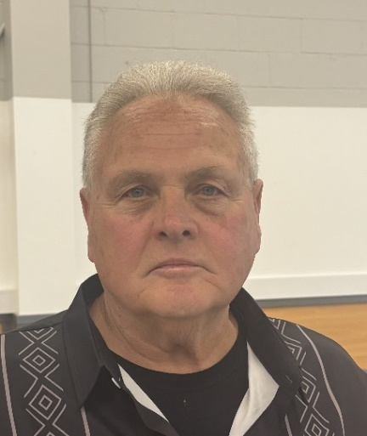

H Hello, my name is John Taglione. I am a lifelong resident of Mechanicville, as is my

entire family, which includes myself, my wife Joy, and my kids. We all graduated from

MHS and proud of it. I taught and coached at MHS for 32 years and I feel fortunate to

have worked here. During my time teaching I taught 4 grade levels and special

education. Along with being on the teaching staff I was the head football coach for 32

years. What a fantastic experience I was fortunate to have.

I I retired 15 years ago and I decided to run for Board of Education. My love for the community and district would not allow me to just fade in the sunset. Presently serving my 15th year, I have just as much vigor and energy as I did when I began.

This budget year has been one of the most difficult I have ever experienced. I

have listened to my constituents at a number of BOE meetings. They were extremely passionate for our students and programs. They have emphasized very clearly their concerns. I listened carefully as I'm sure the other BOE members have. As a result, I along with 2 other BOE members voted no on the first presented budget. It was clear to me we needed to address the important concerns of our community. As a result, we went back to work to find ways how we could provide a more acceptable budget. At the May 1 board meeting the new budget was presented and a new vote from board was taken. The BOE passed the revised proposed budget. My reason to vote yes was solely based on listening to our community and staff.

On May 20, from 12-9pm, in the high school gym, a vote will be held on the school budget, Board of Education election, and other items. I am asking you for your support to once again to be elected to a new term on BOE. Yes, I feel there needs to be changes on a number of things. The community, staff, and administration all need to work together as a TEAM, sharing ideas, concerns, and solutions. That's a priority for me if elected. Our taxpayers are burdened, no doubt about that, and I blame much of that on the state who cannot even pass their own budget on time to help understand exactly what state aid they are providing. Once again, I am asking for your support and vote. I thank you very much.

JOHN TAGLIONE

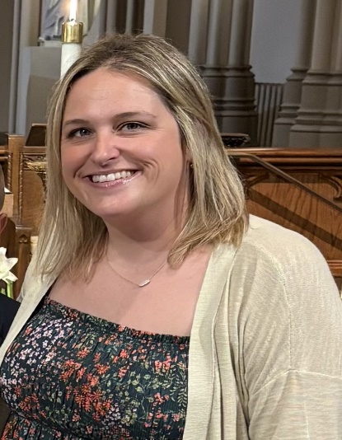

My name is Nichole Gorsky and I’m running for my second term on the Mechanicville CSD School Board. I am a Mechanicville native. Class of 2006 and a third generation Red Raider; My husband Dave and I chose to reside in the Mechanicville City School District and start a family. We have two children. Our oldest is in 4th grade and our youngest is in 2nd.

I want to see our schools succeed. Mechanicville is the best community, and our kids deserve the best in education. During my first term on the Mechanicville CSD School Board, I've been a dedicated advocate for elementary school resources and programs, essential support services for children with special needs, creating an environment where every child can thrive, and build stronger connections between the board and our educators.

Toward the end of my current term I have begun to learn more about the inner-workings and needs of our JSHS. I would be proud to continue this research and support through a second term.

As a board member I would give my full support to the teachers. We cannot support our children without first supporting the faculty and staff who give their all, every day. I am prepared to tackle the quality of education, equity, and fiscal challenges facing us. I hope to earn your vote on May 20 for a spot on the Mechanicville School Board.